**Work, the wasted years**

**在工作中浪费的那些年**

（英文部分选自经济学人20220618期商业版块）

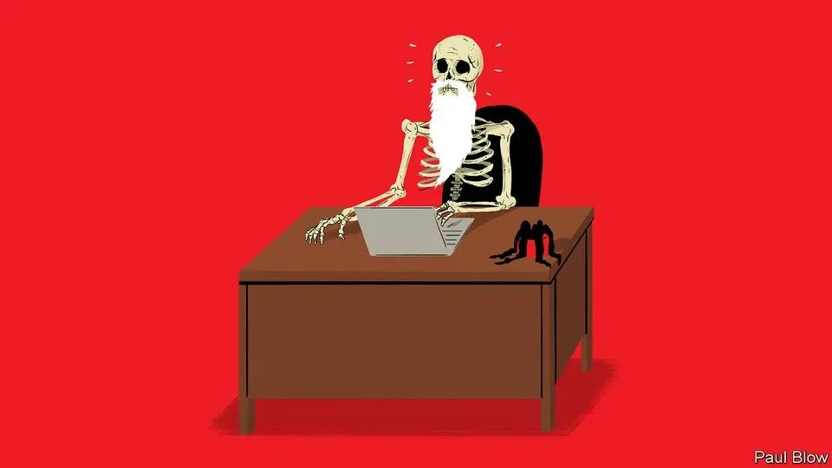

Business | Bartleby

商业 | 巴托比

Work, the wasted years

在工作中浪费的那些年

Logging in, deleting emails, mistyping things. It all adds up

登帐号、删邮件、打错字……浪费之时聚沙成塔

①Few things are more depressing than estimates of how much time people spend on a specific activity over the course of their lives. You know the sort of thing: you will spend one-third of your life asleep, almost a decade looking at your phone and four months deciding what to watch on streaming services.

最令人伤神之事莫过于得知某件事在人的一生中所耗费的时间总和。你知道吗？人的一生中，三分之一的时间在睡觉，近十年的时间在玩手机，仅仅是在流媒体上选择观看内容就要花掉四个月。

②A new study, by academics from the Maryland and Delaware Enterprise University Partnership (madeup), applies this approach to the workplace. By conducting a time-use survey of 5,000 office workers in America and Britain, the researchers identify the number of minutes that people waste on pointless activities each working day. (Meetings are excluded: they often turn out to be useless but not always and not for everyone.) The authors then extrapolate these figures to come up with a “weighted total futility” (WTF) lifetime estimate of time that could have been better spent. The results are literally unbelievable.

来自马里兰和特拉华校企合作组织（此为虚构）的学者们开展了一项新研究，用同样的方式观察职场生活。通过调查美国和英国5000名上班族的时间利用情况，研究人员计算出人们每个工作日浪费在无意义活动上的时间（其中不包括会议：虽然开会常常没多大作用，但并不尽然，也不是对所有人都无益）。接着，通过推断这些数据，研究人员估算了工作时间损耗的“加权无谓值”（英文首字母缩略为“WTF”）。研究结果令人大跌眼镜。

③Correcting typos takes up an average of 20 minutes in every white-collar worker’s day, the equivalent of 180 days, or half a year, over a 45-year career. Some words are mistyped so frequently that on their own they can waste days of the average employee’s existence. “Thnaks” is the worst offender in the English-speaking world, followed by “teh”, “yuo” and “remeber”. The amount of time the average worker spends writing “Bets wishes” is also counted in days.

每名白领平均每天要花20分钟修改错别字，相当于45年的职业生涯中，有半年180天都在做这件事。仅对一些高频错误的修改就可以浪费员工好几天时间。在英语国家中，“Thanks”输错频率最高，容易打成“Thnaks”，其次是“teh”、“yuo”和“remeber”（应该是“the”、“you”、“remember”）。修改“Bets wishes”（应该是“Best wishes”）的时间也多到要以天为单位来计算。

④The gestation period of a goat is around 145 days. Which is also how long the average worker spends logging into things during his or her working life. Security concerns mean that some time is bound to be absorbed in this way. But months are wasted trying to remember passwords, entering them wrongly or updating them. Just as much time is spent waiting for something to happen, a great economy-wide period of vacant staring at a screen.

山羊的妊娠期大约是145天，正好是一名普通上班族职业生涯用于登录各种账号所花费的时间。出于账户安全考虑，定期登录账号的时间没法省。但是回想密码、输错密码以及更改密码会浪费几个月的时间。呆呆地盯着屏幕、等待登陆进系统，这同样要花上几个月，这种情况在各个行业都很普遍。

⑤If getting into things wastes lots of time, so does closing them down. Eliminating help windows and tool-tip boxes takes up days over a career. Rejecting repeated requests to schedule updates to your operating system is another chunk of existence that you will never get back. Zapping pop-up ads and trying to pause auto-playing video absorbs time that could have been spent learning to knit or visiting Machu Picchu.

除了登录，关闭过程同样耗时不短。彻底关闭帮助窗口和提示框会浪费数天时间。反复拒绝操作系统的更新指令也会让大量时间一去不复返。清除弹窗广告以及暂停自动播放的视频所耗费的时间足够人们学习编织或去马丘比丘旅游。

⑥**A bundle of** “**tidying up**” activities absorbs over four months of the average worker’s life. Deleting emails takes up about six weeks of your life. Clicking on Slack channels to read through messages that are not meant for you, or clearing notifications on your phone screen for articles that you will never look at: tasks like these each eat up several days.

在打工人的职业生涯中，花在“清理”活动上的时间超过四个月。删除邮件会消耗掉大约六周的时间。在Slack频道里浏览和自己无关的信息，或者是清理掉手机上从来不看的文章提醒，诸如此类的每件事情都会花掉几天的时间。

⑦Various types of formatting tasks constitute another huge time-suck. Think of those attempts to change the margins on Word or Google documents, or the hours spent trying to work out where exactly you need to put the missing bracket in that broken spreadsheet formula. Shakespeare wrote “King Lear” in the time an average office worker spends changing font sizes during their career.

另一个耗时大户是各式各样的格式调整。回想一下，你是否曾经反复调整Word或谷歌文档的页边距，或者发现电子表格无法运行，花了几个小时才找到公式中缺少括号的位置。一个上班族在职业生涯中花费在调整字号上面的时间，都够莎士比亚写出《李尔王》了。

⑧Redoing work that you have failed to save is in a category all of its own, because of the psychological trauma involved. This problem has been mitigated now that revisions are saved automatically on many programs, but it has not been solved. Batteries still run out at crucial moments, internet connections still fail. Making a series of deeply insightful comments in a Google doc, failing to save them and then closing everything down causes a special kind of despair. So does creating an org chart with hundreds of arrows and text boxes, and realising you missed someone out.

文件未保存导致的重复工作因其造成的心理创伤而自成一类。现在许多程序都能自动保存修改，问题虽得到了缓解，但是并未完全解决：电量仍有可能在关键时刻告罄，网络也可能连接失败。试想一下，你在谷歌文档中批注了一连串的深刻见解，但没有保存就退出了，这时你将品尝到一种独特的绝望。这种绝望同样发生在：好不容易画了张由数百个箭头和文本框组成的组织结构图，却发现漏掉了某个人。

⑨These are only some of the many ways in which time is routinely wasted. Co-ordinating diaries for meetings that will later be cancelled: another month. Waiting for people to repeat themselves because they were on mute by mistake: a fortnight. Spending hours crafting an email and then leaving it in the drafts folder: two days. Desperately opening and shutting various flaps on a recalcitrant printer: a day.

日常浪费时间的方式众多，以下为不完全列举。协调各种会议日程，结果会议取消了：一个月。等待误开静音的人重复他们的发言：两个星期。花几个小时精心编辑一封电子邮件，然后将其永远留在草稿箱中：两天。面对不听话的打印机，拼命地打开又关上各种盖板：一天。

⑩The madeup study shows that technology lies at the heart of this squandered time. Technology can also help. Services that sync up diaries and autocorrect options already do; passwords will doubtless end up being replaced by facial recognition and fingerprint logins. Whether the time thereby saved would be put to more productive use, like reading this column, is a reasonable question. But years of workers’ lives are wasted on utterly pointless activities. All improvements warrant heartfelt thnaks.

这项虚构研究表明，技术是工作时间浪费的关键因素。但是技术也可以提供帮助，现有技术已经支持同步日志和接受自动更正，密码也无疑将被面部识别和指纹登录所取代。虽然由此省下的时间能否投入更有益之事，如阅读本专栏，仍值得质疑。但考虑到上班族被无谓的活动耗掉的数年光阴，任何改进都值得由衷的蟹蟹（thnaks)。